**An Artificial intelligent system to identify Alzheimer's disease using brain MRI**

**Riya Das**1**, Aparna Tiwary2 and Sk Aayan Rahaman3**

1School of Advanced Sciences, VIT Chennai, riya.das2022a@vitstudent.ac.in

2School of Advanced Sciences, VIT Chennai, aparna.tiwary2022@vitstudent.ac.in

3School of Advanced Sciences, VIT Chennai, skaayan.rahaman2022@vitstudent.ac.in

S. Dhanasekar, Mathematics Division, School of Advanced Sciences, dhanasekar.sundaram@vit.ac.in

**Abstract**

The accurate identification and diagnosis of Alzheimer's disease (AD) is a critical challenge in the field of mental health. In recent years, there has been a growing interest in leveraging artificial intelligence (AI) techniques, particularly brain magnetic resonance imaging (MRI) analysis, to aid in the diagnostic process. This research paper presents an innovative AI system that utilizes brain MRI data for the identification of AD. The proposed system employs a comprehensive methodology that integrates image processing techniques and machine learning algorithms. Initially, the brain MRI scans undergo pre-processing steps to enhance image quality and extract relevant features. These features capture structural, functional, and connectivity information from different regions of the brain. Subsequently, a machine learning model, trained on a large dataset of labelled brain MRI scans, is employed to classify, and identify AD. Various machine learning algorithms, including deep learning models, are explored to achieve optimal accuracy and generalization. The model is trained to recognize patterns and associations between the extracted features and the specific psychiatric disorder. Finally, we discuss the challenges, opportunities, and future study directions of our model.

Keywords— Alzheimer's disease (AD); mental health; artificial intelligence; brain MRI; image processing; machine learning; deep learning.

1. **Introduction**

Alzheimer's disease is a degenerative neurological disorder characterized by progressive cognitive decline and memory loss. Early detection of Alzheimer's disease is crucial for effective treatment and management. In recent years, there has been a significant advancement in the field of artificial intelligence (AI) and medical imaging, opening up new possibilities for early and accurate diagnosis of Alzheimer's disease.

In this paper, an innovative artificial intelligence system has been developed to identify Alzheimer's disease using brain magnetic resonance imaging (MRI) scans. This AI system leverages state-of-the-art machine learning algorithms and deep neural networks to analyze MRI images and detect specific patterns indicative of Alzheimer's disease. It has the potential to revolutionize the field of neurology, providing accurate and efficient diagnosis, facilitating timely interventions, and ultimately improving patient outcomes.

One of the key advantages of this AI system is its ability to detect Alzheimer's disease in its early stages, even before visible symptoms manifest. Early detection enables timely interventions and treatments that may help slow down disease progression and improve the patient's quality of life.

It is important to note that this AI system should be used as a supportive tool for healthcare professionals rather than a standalone diagnostic tool. The final diagnosis should always be made by qualified medical experts who consider multiple factors, including the AI system's output, clinical history, and additional diagnostic tests.

1. Literature Review

B. Khagi[1] et al. presents a study conducted to distinguish between healthy and Alzheimer's patients using CNN models, like AlexNet, GoogleNet, ResNet50. The methodology involved using MRI images from the OASIS dataset and training various CNN architectures. The results demonstrate the effectiveness of CNN models in accurately classifying patients with high accuracy and provide insights for Alzheimer's disease diagnosis. Wang[2] et al. proposes a classification approach for Alzheimer's disease using an eight-layer convolutional neural network (CNN) with leaky rectified linear units (ReLU) and max pooling. The methodology involves training the CNN model on a large dataset of brain MRI images. The results show that the proposed model achieves an high accuracy of 97.65% in classifying Alzheimer's disease, demonstrating its potential for clinical diagnosis and treatment. M. Hon[3] et al. presented a methodology for Alzheimer's disease classification using transfer learning. They applied pre-trained deep learning models and fine-tuned them on Alzheimer's disease data, achieving promising results with high classification accuracy. The study demonstrated the potential of transfer learning as an effective approach for Alzheimer's disease diagnosis. J. Islam[4] et al presents a deep convolutional neural network (CNN) specifically designed for Alzheimer's disease diagnosis using brain MRI data analysis. Unlike existing approaches that focus on binary classification, this model is capable of identifying different stages of Alzheimer's disease. R. Mahmood[5] et al. proposes a methodology for the automatic detection and classification of Alzheimer's Disease using MRI scans. The approach combines Principal Component Analysis (PCA) for feature extraction and Artificial Neural Networks (ANN) for classification. The results demonstrate the effectiveness of the proposed method in accurately identifying Alzheimer's Disease from MRI scans. The accuracy for this method was close to 90%.

P. Prasad[6] et al. proposes an AI-based strategy for segmentation in brain MRI images, using Convolutional Wavelet Network (CWN) and SoftMax classification, achieving 99.44% accuracy and high DSC values. Graham S[7] et al. explores the potential of AI technology in revolutionizing mental healthcare while acknowledging its possible drawbacks. It provides an overview of AI and its applications in healthcare, focuses on recent research related to AI in mental health, and discusses how AI can complement clinical practice while recognizing its limitations. P. Yin[8] et al. introduces a deep guidance network for segmenting biomedical images, restoring structure information through guided image filters. It enables end-to-end training and fast inference, with extensive experiments on publicly available datasets. The objective of Nilson[9] is to identify challenges and opportunities associated with the utilization of artificial intelligence (AI) in mental healthcare. It also aims to provide key insights from implementation science that can aid in understanding and facilitating the implementation of AI in this field. E. Hussain[10] et al. presents a 12-layer CNN model for binary classification and detection of Alzheimer's disease using brain MRI data. The model achieves 97.75% accuracy, surpassing existing models and demonstrating superiority over pre-trained CNN models.

Abdulhamit Subasi[11] provided an overview and summary of recent research and advancements in the use of artificial intelligence (AI) techniques for processing and analysing medical images in the detection of Alzheimer's disease (AD). Numerous studies have explored and implemented various AI techniques, particularly computer-aided detection (CAD) systems, for the purpose of automatic AD detection. The primary goal has been to develop a reliable, yet simple and efficient model for identifying AD using AI techniques. The study focused specifically on the application of AI techniques for AD detection using brain images. It also provided an overview of image processing, feature extraction, and machine learning methods that have been employed in AD detection. Kuo Yang[12] et al. presented a comprehensive examination of recent studies focusing on the utilization of deep learning algorithms for assessing dementia progression, diagnosing the early stages of Alzheimer's disease (AD), and discussing future prospects in this research area. The review covered a range of applications of advanced AI algorithms in AD diagnosis, such as Convolutional Neural Networks (CNNs), Recurrent Neural Networks (RNNs), Automatic Image Segmentation, Autoencoders, Graph Convolutional Neural Networks (GCNs), Ensemble Learning, and Transfer Learning. Guang-Di Liu[13] et al. provided a concise overview of the use of artificial intelligence (AI) applications in psychiatric research and diagnosis, focusing on three main brain observation techniques: magnetic resonance imaging (MRI), electroencephalography (EEG), and kinesics diagnoses. The study examined how AI have been applied to these techniques, including the algorithms used. Additionally, it discussed the challenges, opportunities, and potential future directions for AI-based applications in psychiatric research and diagnosis. Kalmady[14] et al. uses RS fMRI data to distinguish between antipsychotic drug treatment-naïve patients with schizophrenia and healthy controls. They propose an ensemble model called EMPaSchiz(‘Emphasis’) that combines predictions from multiple single-source models focusing on regional activity and functional connectivity features using different pre-defined parcellation schemes. Ahed Abugabah[15] et al.proposes a healthcare intelligent system using a deep convolutional neural network (DCNN) to classify individuals into NC, MCI, AD categories based on WM and GM tissue analysis from MRI data. The model achieved high accuracies: NC versus AD (97.94%),MCI versus AD (92.84%), and NC versus MCI(88.15%) using GM images.

1. **Methodology**

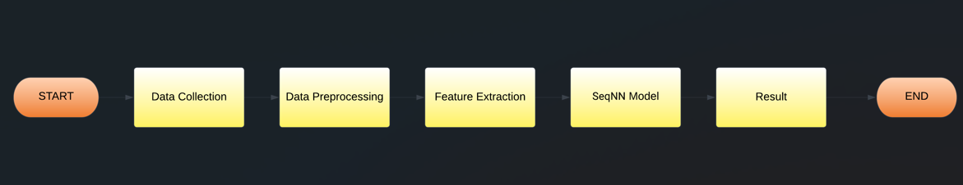

**2.1. Data Collection**

Data is collected from the open-source OASIS (Open Access Series of Imaging Studies). This dataset comprises a group of 416 individuals, ranging in age from 18 to 96 years. Each individual in the dataset has undergone 3 or 4 separate MRI scans, specifically T1-weighted scans, all acquired in a single scan session. The participants included in the dataset are a mix of men and women who are all right-handed. Notably, among the participants, there are 100 individuals over the age of 60 who have received a clinical diagnosis of very mild to moderate Alzheimer's disease (AD). Additionally, the dataset includes a separate reliability dataset consisting of 20 individuals without dementia who were re-imaged within 90 days of their initial session.

A sample of the MRI used is shown below-

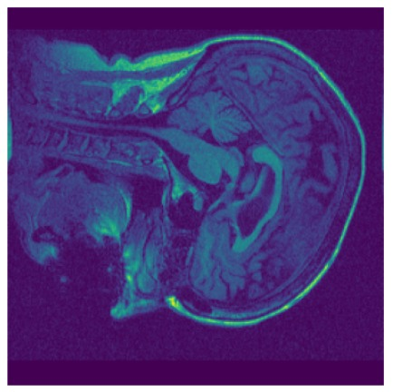

**2.2. Data Preprocessing**

*2.2.1. Skull stripping*

In brain MRI, skull stripping refers to the process of removing non-brain tissues, such as the skull and scalp, from the image to isolate the brain for further analysis. It is commonly performed using automated algorithms that utilize intensity thresholds, region-growing methods, or machine learning techniques to segment the brain from the surrounding tissues. This step is crucial for accurate measurement and analysis of brain structures and pathology in neuroimaging research and clinical practice. For this step, deepbrain library has been used.

*2.2.2. Denoising*

This method utilizes the SimpleITK library to perform bias correction on a 3D image. It starts by reading the image from a specified source path and converting its pixel values to the sitkFloat32 type. Subsequently, a binary mask is created to identify areas of the image with uneven intensity. The N4 bias field correction algorithm is then employed on the input image, taking into account the generated mask.

*2.2.3. Image Segmentation*

It involves dividing the MRI image into different regions or segments, typically corresponding to different anatomical structures or pathology. It is performed using various algorithms, including thresholding, region-growing, or machine learning-based approaches, to accurately delineate and identify different brain regions of interest. This segmentation process is crucial for quantitative analysis, visualization, and diagnosis in neuroimaging research and clinical applications. TissueClassifierHMRF object from dipy library has been used for this purpose. 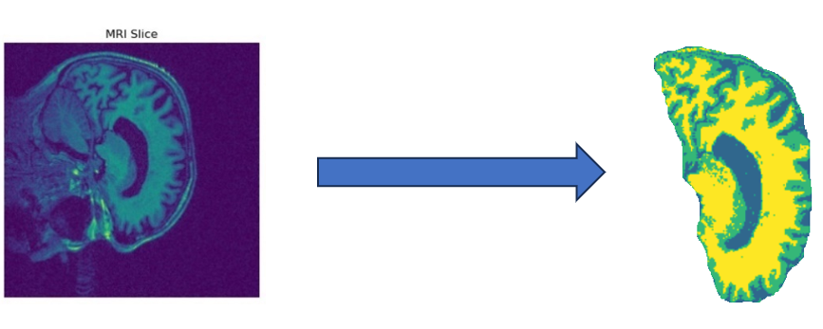

*2.2.4. Feature Extraction*

Contrast, dissimilarity, homogeneity, energy, and correlation are statistical measures used to quantify different aspects of texture or spatial relationships within MRI images:

* Contrast: It quantifies the variation in intensity between adjacent pixels, indicating how sharp or distinct the boundaries are between different structures within the image.
* Dissimilarity: It evaluates the range or dissimilarity in intensity values among neighboring pixels, providing insights into the heterogeneous or variable nature of texture within the image.
* Homogeneity: It shows the consistency or likeness of intensity values among neighboring pixels, indicating the existence of smooth or regular texture patterns.
* Energy: This measures the level or intensity of texture patterns present in the image, reflecting the overall quantity or distribution of texture throughout the image.
* Correlation: The correlation measures the linear dependency or relationship between neighbouring pixel intensities, indicating the presence of spatially coherent or structured patterns.

These measures are commonly used in image analysis and feature extraction techniques to characterize and differentiate textures or spatial patterns in MRI images, which can assist in various tasks such as segmentation, classification, and detection of abnormalities or disease markers.

* 1. **Model Building**

A sequential neural network model with two hidden dense layers containing 16, 8 units with ‘relu’ activation function has been used. The loss function and optimizer that have been used are binary_crossentropy and adam respectively.

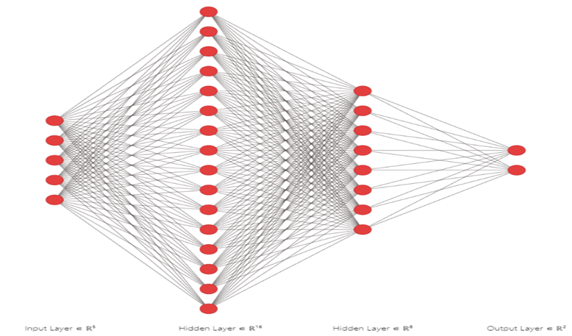

* + 1. *Sequential Neural Network*

A sequential neural network, also known as a sequential model, is a type of artificial neural network architecture commonly used in deep learning. It is designed to process sequential data, such as time series data or text data, where the order of the input elements matters.

It is composed of multiple layers of neurons, which are arranged in a sequence or a stack. Each layer in the network receives input from the previous layer and passes its output to the next layer. This sequential flow of information allows the network to learn patterns and dependencies in the input sequence.

* + 1. *Binary Crossentropy*

Binary Crossentropy is a loss function commonly used in binary classification tasks in machine learning and deep learning. It measures the dissimilarity or difference between the predicted probability distribution and the true binary labels of a dataset.

* + 1. *Adam Optimizer*

The Adam optimizer is an optimization algorithm commonly used in machine learning, particularly in deep learning, for training neural networks. It combines the concepts of adaptive learning rates and momentum to efficiently update the network's weights during training.

**4.Results and Discussions**

In our experiment, we have used the OASIS dataset. After preprocessing and feature extraction, we obtain a csv dataset with 5 features and 1 target variable having labels as demented and non-demented. We used Sequential Neural Network and achieved an accuracy of 70.02% and loss function value of 0.6196 after 15 epochs.

**5.Conclusions**

The development of an artificial intelligence system to identify Alzheimer's disease using brain MRI holds great promise for early detection and accurate diagnosis. By leveraging advance

machine learning algorithms and neural network architectures, such a system can analyze brain MRI images and extract relevant features indicative of Alzheimer's disease pathology.

Our proposed model can aid anyone in making more informed decisions even after not having medical expertise. Early detection can lead to timely interventions and personalized treatment plans, potentially slowing disease progression and improving patient outcomes.

1. **Further Scope**

Due to computational limitations and lack of reliable large dataset, we had to train our model on a relatively small dataset. In the future, we can improve our accuracy using a larger dataset and a better system.

1. **References**
2. B. Khagi, B. Lee, J. Pyun and G. Kwon,” CNN Models Performance Analysis on MRI images of OASIS dataset for distinction between Healthy (i.e., Non-Demented) and Alzheimer’s patient (i.e., Demented),” 2019 International Conference on Electronics, Information and Communication (ICEIC), Auckland, New Zealand, pp. 1-4, 2019.
3. S. Wang, P. Phillips, Y. Sui et al.” Classification of Alzheimer’s Disease Based on Eight-Layer Convolutional Neural Network with Leaky Rectified Linear Unit and Max Pooling”, J Med Syst, vol. 42, no. 85, 2018.
4. M. Hon and N. M. Khan,” Towards Alzheimer’s disease classification through transfer learning,” in Proc. IEEE International Conference on Bioinformatics and Biomedicine (BIBM), Kansas City, pp. 1166-1169, 2017.
5. J. Islam, Y. Zhang,” A Novel Deep Learning Based Multi-class Classification Method for Alzheimer’s Disease Detection Using Brain MRI Data,” in Proc. International Conference on Brain Informatics, pp. 213-222, 2017.
6. R. Mahmood and B. Ghimire,” Automatic detection and classification of Alzheimer’s Disease from MRI scans using principal component analysis and artificial neural networks,” in Proc. 20th International Conference on Systems, Signals and Image Processing (IWSSIP), Bucharest, pp. 133-137, 2013.
7. P. Prasad and A. Mishra, "AI Based Segmentation Technique to Identify Abnormality in MRI Images," 2023 IEEE International Students' Conference on Electrical, Electronics and Computer Science (SCEECS), Bhopal, India, 2023, pp. 1-6, doi: 10.1109/SCEECS57921.2023.10063040.
8. Graham S, Depp C, Lee EE, Nebeker C, Tu X, Kim HC, Jeste DV. Artificial Intelligence for Mental Health and Mental Illnesses: an Overview. Curr Psychiatry Rep. 2019 Nov 7;21(11):116. doi: 10.1007/s11920-019-1094-0. PMID: 31701320; PMCID: PMC7274446.
9. P. Yin, R. Yuan, Y. Cheng and Q. Wu, "Deep Guidance Network for Biomedical Image Segmentation," in IEEE Access, vol. 8, pp. 116106-116116, 2020, doi: 10.1109/ACCESS.2020.3002835.
10. Nilsen P, Svedberg P, Nygren J, Frideros M, Johansson J, Schueller S. Accelerating the impact of artificial intelligence in mental healthcare through implementation science. Implement Res Pract. 2022 Jul 11; 3:26334895221112033. doi: 10.1177/26334895221112033. PMID: 37091110; PMCID: PMC9924259.
11. E. Hussain, M. Hasan, S. Z. Hassan, T. Hassan Azmi, M. A. Rahman and M. Zavid Parvez, "Deep Learning Based Binary Classification for Alzheimer’s Disease Detection using Brain MRI Images," 2020 15th IEEE Conference on Industrial Electronics and Applications (ICIEA), Kristiansand, Norway, 2020, pp. 1115-1120, doi: 10.1109/ICIEA48937.2020.9248213.
12. Abdulhamit Subasi, Chapter 11 - Use of artificial intelligence in Alzheimer’s disease detection, Editor(s): Debmalya Barh, Artificial Intelligence in Precision Health, Academic Press,2020, Pages 257-278, ISBN 9780128171332,https://doi.org/10.1016/B978-0-12-817133-2.00011-2.
13. Yang, K., & Mohammed, E. A. (2020). A review of artificial intelligence technologies for early prediction of Alzheimer's disease. *arXiv preprint arXiv:2101.01781*
14. . Guang-Di Liu, Yu-Chen Li, Wei Zhang, Le Zhang, A Brief Review of Artificial Intelligence Applications and Algorithms for Psychiatric Disorders.
15. Kalmady, Sunil & Greiner, Russ & Agrawal, Rimjhim & Shivakumar, Venkataram & Narayanaswamy, Janardhanan & Brown, Matthew & Greenshaw, Andrew & Dursun, Serdar & Venkatasubramanian, Ganesan. (2019). ARTICLE Towards artificial intelligence in mental health by improving schizophrenia prediction with multiple brain parcellation ensemble-learning. npj Schizophrenia. 5. 10.1038/s41537-018-0070-8.
16. Abugabah, Ahed & Mehmood, Atif & Almotairi, Sultan & Al Smadi, Ahmad. (2022). Health care intelligent system: A neural network based method for early diagnosis of Alzheimer's disease using MRI images. Expert Systems. 39. 10.1111/exsy.13003.